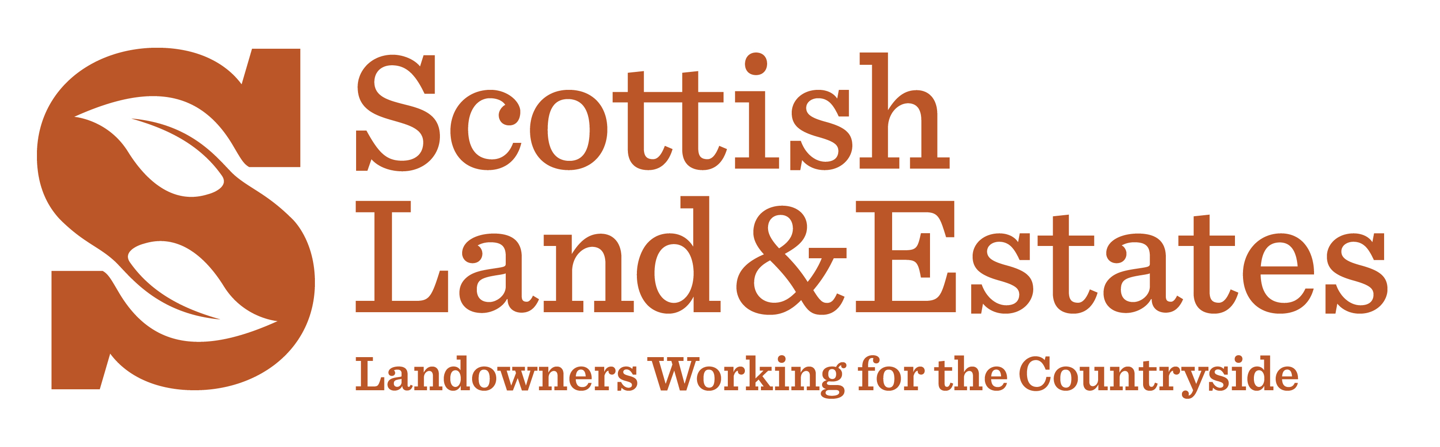
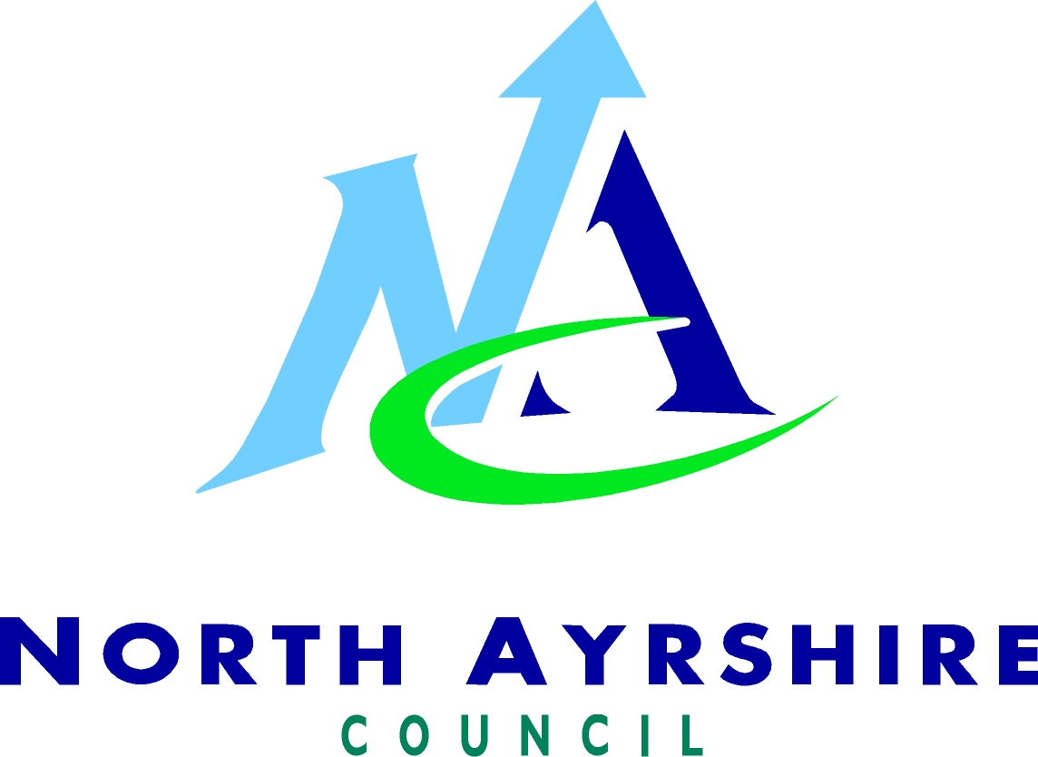

Case Study: Utilising LEADER Funding for responsible access promotion and education in North Ayrshire

Access Issue/s
Successfully obtaining funding
Positively influencing access users
Promotion of the Scottish Outdoor Access Code and understanding the working countryside

Key Facts
Project Lead: Louise Kirk, Access Officer, North Ayrshire Council
Funding partners: Argyll and Islands LEADER, Ayrshire LEADER, the NHS (Healthy North Ayrshire), North Ayrshire Council, Irvine Bay Regeneration Company and other smaller funders.

Inspiration
To produce new leaflets for each town and village in North Ayrshire which encourage and promote use of local routes for enjoyment and health benefits, coupled with information on how to interact with the countryside in ways which are responsible. To replicate leaflet information on the North Ayrshire paths website and build upon the guidance given in the Scottish Outdoor Access Code.

LEADER Funding
LEADER Funding is an element within the Scottish Rural Development Programme. It is aimed at promoting economic and community development within rural areas. Support is aimed primarily at small-scale, community driven projects that are pilot and innovative in nature. Funding is awarded by Local Action Groups (LAGs) who take decisions on projects which are community driven and have a wide community benefit. For more information on LEADER and LAGs visit www.scotland.gov.uk/Topics/farmingrural/SRDP/LEADER

There is potential for LEADER funding to deliver a range of outdoor access initiatives which are for the benefit of rural communities. LEADER will not be suitable to deliver all types of access provision and land managers are generally directed to apply through the Land Management Options or Rural Priorities schemes. However where the right mix of innovation and rural community involvement exists, land managers may wish to work as a partner in community or local authority led LEADER projects.

The Project
North Ayrshire Council’s Local Access Officer in partnership with the North Ayrshire Outdoor Access Forum, successfully made an application for LEADER funding to Ayrshire LAG and Argyll and Islands LAG. Funding was also obtained from the NHS (Healthy North Ayrshire), North Ayrshire Council, the Urban Regeneration Company and some other smaller funders. Using this combination of funding streams, it was possible to secure £60,000 which represents 100% funding.

The funding delivered new leaflets for each town and village in North Ayrshire and added information to the North Ayrshire Paths website.

The leaflets and website give:-
- General information about the town or area
- Maps with local routes, including start and end points and, where possible, path surface type
- Local information, including toilets, transport, access points to inland water, community facilities, points of interest, visitor attractions and local heritage information.
- Key messages from the Scottish Outdoor Access Code, plus local land management information.
- Information on the health benefits of outdoor access

The leaflets therefore deliver a wide range of complementary information which meets a range of objectives. These include:-

- Promoting responsible enjoyment of the outdoors
- Promoting the health benefits of being in the outdoors
- Promoting local tourism
- Promoting awareness of the local environment and land management issues.

The new leaflets compliment the existing guidance leaflets produced by the Council such as the Paws for Thought guide to responsible dog walking and ownership. In addition to this information on responsible access targeted at dog walkers, horse riders and general access users is incorporated into the Ayrshire Paths website. This includes seasonal information on land management activities.

North Ayrshire’s Access Officer points out that it was the wide ranging benefits that the leaflets aim to deliver that were attractive to potential funders. This ultimately enabled her to gain funding for the project from a variety of different sources. She also points out that once part-funding is secured from one source it can be easier to convince other funders to come onboard with a project.

The information on local land management was developed in consultation with farmers and land managers in North Ayrshire.
This information sheet was originally written by Scottish Land & Estates for inclusion in its “Managing Access” guidance booklet for landowners and managers.

